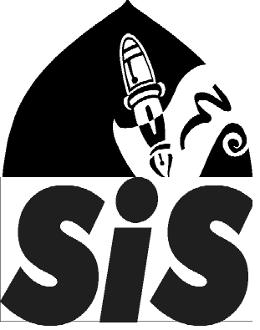
Saturday Islamic School
East London Mosque & London Muslim Centre

email: admin@saturdayislamicschool.co.uk http://www.saturdayislamicschool.co.uk

providing high quality Islamic education and learning since April 1996

Application for new to SIS from September 2022

You are requested to read the attached guidance carefully and complete all sections of this form.

- Only the information given on this form will be used for short-listing children for the interviews.
- Minimum age for admission to SIS is 6 years old. Complete section 4 for children aged 7 years and over - those under 7 years do not need to complete section 4.
- Children aged 11 or over must be able to read and write Arabic language as they will be studying for Arabic language equivalent to GCSE level. Children aged 11 years or over are catered for at LMC only.

Section 1: Details of parents/applicants
Father’s name |  |  |  |  | Mother’s name
Address with full postcode
Home telephone number |  |  |  |  |  | Mobile
Email
Emergency contact (name and telephone number)

Section 2: Details about the child
Child’s full name
Child’s date of birth |  |  |  | Age
Briefly state child’s experiences of learning at home

You may continue on a separate paper if required.
SIS has 5 branches in Tower Hamlets – (1) Bow School (BS); (2) Mulberry Academy Shoreditch (MAS); (3) Stepney Green School (SG), and (4) St Paul’s Way Trust School (SPW). Please write your preferences in order of your choice in the boxes* |  |  | 1st Choice |  | 2nd Choice |  | 3rd Choice

LMC is only for children aged 11 years and over and does not cater for younger children. All other branches cater for children aged 6 to 11 years.

Section 3: Medical information
Does your child have any medical conditions?
(e.g. conditions for which regular medication is required)
Is your child allergic to anything?
Please use this space to provide any other medical or health related information

Section 4: Only to be completed by children aged over 7 years old
Please write the name of the Surahs that your child has fully memorised from the Qur’an. It is important that you assess your child before completing this as wrong assessment may disadvantage your child.

The completed form can be submitted by hand to the main reception of the East London Mosque.
Forms can be posted to: Saturday Islamic School, 84-92 Whitechapel Road, London E1 1JX

Forms can also be emailed to admin@saturdayislamicschool.co.uk in PDF format only
SIS will not take responsibility for lost applications or applications sent by other means.

Agreement – all parents must read and sign this agreement
- I have read and understood the ‘fact sheet for parents and guardians’ attached to this form.
- The information provided on this form is complete and accurate to the best of my knowledge.
- I understand that eligible children and their parents will be invited for an enrolment interview at the branch which will determine the outcome of this application.
- If my child is offered a place, I agree to abide by all the rules and regulations of the Governing Body of Saturday Islamic School.
- I will inform the school of any changes to my contact details or my child’s needs.
- Fee (parental contribution) is £210 (which includes admissions fee and a starter pack). The school does not offer reduced fees for siblings. This must be paid at the enrolment interview and before the child starts SIS.

Name of parent |  | Signature |  | Date

SPACE BELOW IS FOR OFFICIAL USE ONLY

Verification of information on application form |  |  |  |  |  | Use this space to record any other information including the outcome.
Verification of P/Aspirations
Percentage of attendance on last school report
Name of sibling & class
Child’s S &
Child’s R
Child’s W
SEN |  |  | MAP
Arabic
Other:

